Healthcare Process Improvement – Lean Improvement Approach

ISE 251 – Course Project Report

Samarth Bhargava, Shyam Sundar Krishnan, Rakesh Manjunath, Huai-Chen Shih

San Jose State University

Table of Contents

Abstract 5

Introduction 6

Project Constrain 6

Communication with Healthcare Center 7

Define Phase 7

Project Charter 7

Project Overview 7

Problem Statement 8

Project Scope 8

Project Deliverables 9

Project Measurements 9

Project Resources 9

SIPOC 9

Measure Phase 10

Data Collection and Measurement 10

Pareto Chart 12

Analyze Phase 13

Ishikawa Diagram 13

Root Cause Validation 13

Improve Phase 14

Failure Mode and Effects Analysis (FMEA) 14

RPN Prioritization Table 15

FMEA Table 15

Root Cause Analysis and Feasible Solution 15

Improvement using 5S 16

Learning and Future Improvement Ideas 17

Key Learning 17

Future Improvement Ideas 17

Control Phase 18

Control Chart 18

Before Process 18

After Process 19

Hypothesis Testing 19

Turn Around Time 19

Error Frequency 20

Conclusion 21

Appendix 23

References 24

Table 1. Schedule of the Project. 8

Table 2. SIPOC 10

Table 3. Process Cycle Time 11

Table 4.Billing Errors 11

Table 5. Root Cause Validation 14

Table 6. RPN Prioritization Table 15

Table 7. FEMA Table 15

Table 8. Root Cause Analysis and Feasible Solution 16

Table 9. TAT Before and After 20

Table 10. F-test 20

Table 11. T-test Assuming Equal Variances 20

Table 12. Error Frequency Before and After 21

Table 13. T-test Paired Sample 21

Figure 1. Pareto Chart of Turn Around Time 12

Figure 2. Pareto Chart of Billing Error 13

Figure 3. Ishikawa Diagram 13

Figure 4. Control Chart Before Process 18

Figure 5. Control Chart After Process 19

Figure 6. Value Stream Mapping Before State 23

Figure 7. Value Stream Mapping After State 23

# Abstract

The main purpose of this project is to apply Lean Technology and Six Sigma Tools for the improvement process at the XYZ Healthcare. The main objective of this project being to access and analyze the process followed by the organization and provide for a possible solution for the improvement of the process. Solution to reduce the service time for each customer and reduction in the number of error occurring during the whole process increasing the quality and customer satisfaction by the process. Initial analysis of the procedure followed by the healthcare provider revealed that the time taken by the organization was higher compared to other providers having a negative impact on the profits. By using Lean Technology and performing a root cause analysis we determined the main causes of the delay in the process. We decided to move forward with Define Measure Analyze Improve Control (DMAIC) approach applying Lean tools along with it like 5S method and value stream mapping technique improving the time taken by the organization and providing them with recommendations for continuous improvement.

Healthcare Process Improvement – Lean Improvement Approach

ISE 251 – Course Project Report

# Introduction

Lean Technology or Lean Methodology mainly focuses on techniques for waste reduction. Companies and organizations all over the world are adopting Lean Methods and Six Sigma Continuous Improvement techniques to reduce the amount of waste in their process and achieve optimized use for their resources through continuous improvement. Lean technology helps identifying the root cause of the problem, making small changes in the process reducing the overall process time. Lean Methodology strives to provide a possible solution that can be used to overcome issues related to quality, quantity and customer satisfaction.

XYZ Healthcare is one of the leading healthcare provider for people living in the bay area. Since the organization works on providing services to many individuals they need to maintain a minimum service time per customer in order to provide higher customer satisfaction. The main problem faced by the organization is due to the high waiting time the customer has to face in order to avail services. Other major issue was the amount of errors occurring during the process increasing the wait time per customer leading to waste with respect to time and resources. We have decided to use the Lean Techniques and tools to identify the issues, find the root cause of the problem and recommend the company the feasible solution.

# Project Constrain

* The financial data is not given by XYZ healthcare center. The economic analysis could not be provided in the project.
* This is an one month project. Little improvement could be provided by the project.

# Communication with Healthcare Center

During the data collection for the project, we communicated with the hospital staff about their perception, opinions and ideas on the existing process. We conducted structured interview, to ensure clarity in questions and obtain insights of the existing process. We obtained information about the training, planning, physical work environment, work attitude of other health center staff, services provided to patients, daily routines and asked to elaborate on changes needed in the process. The interviews were conducted in private compartments to guarantee privacy. The staff had the right to deny answering any question. After implementation of the process improvement the staff were asked to elaborate on the changes observed in the environment. Health center staff were asked to provide suggestions for improving the quality of health services provided to patients.

# Define Phase

Define phase is the first step of the DMAIC. The purpose of define phase is to define the problem statement, the scope of the project, the goal of the project, the schedule of the project, and the recourses that are available to the project. A project charter is provided to show the problem, scope, goal, and resources of the project. Also, an SIPOC diagram is provided to show the process of the hospital billing system.

## Project Charter

### Project Overview

Lean management is a process improvement technique to identify wastes generated in the processes to eliminate them. Hospital billing is a complex, problematic and prolonged process. Every step in this process has the possibility for administrative waste - excessive paperwork, back and forth communications between provider and payer, delay in transfer of claims due to redundant edits and checks, wastes generated due to billing errors and reprocessing. XYZ healthcare center aims to provide leading medical services to people. This healthcare center is experiencing significant challenges in effectively managing accurate billing for patients and payers for the services they provide.

### Problem Statement

How to reduce the total wait time for the billing process involved in XYZ healthcare center? The current billing system used by the XYZ healthcare center has a long process having problems relating to the wait time and the defects in the billing statements. Waiting time is the idle time when people, material, information or equipment is not ready. The defects during the billing cycle causes waste in time as the whole process needs to be repeated again. The problems are present in almost all the processes involved in the billing cycle and is faced by the provider, payer and the patient.

The patients and the provider complain about the long waiting time involved in the billing process which harms the reputation of the organization. It could cause a decline in the number of patients registering with the healthcare provider.

### Project Scope

The objective of this project is to improve the efficiency of the billing system in the healthcare center by eliminating the wastes in the process. By focusing on the errors in the billing system and reducing the wait time involved in the billing process.

|  |  |  |  |
| --- | --- | --- | --- |
| **Phase** | **Start** | **Finish** | **Description** |
| Define | 10/10/2017 | 10/10/2017 | Project Kick-off Meeting |
| 10/11/2017 | 10/16/2017 | Determine the current process used by the healthcare provider. |
| Measure | 10/17/2017 | 10/23/2017 | Collect the data required for the project. |
| Analyze | 10/24/2017 | 10/30/2017 | Analyze the current methodology used by the healthcare provider and implement new methodology to improve the performance. |
| Improve | 10/31/2017 | 11/06/2017 | Implement various improvement process and analyze the efficiency of the billing process. |
| Control | 11/07/2017 | 11/13/2017 | Implement further advancements to the improvement process for further improvement. |

Table 1. Schedule of the Project.

### Project Deliverables

1. Reducing wait time involved in documentation process like - capturing patient information, waiting for approvals and signatures, on hold for getting patient’s insurance information, waiting time of payer review of medical claim.
2. Elimination of billing system errors - system errors, miscoded logic and claim denials, clinical transcriptional errors where information was not, registration errors of patient demographic information.

### Project Measurements

1. The complete healthcare process cycle time
2. The percentages of errors

### Project Resources

1. Project team members
   * Samarth Bhargava
   * Shyam Sundar Krishnan
   * Rakesh Manjunath
   * Huai-Chen Shih
2. XYZ Healthcare management
3. The information of the healthcare process

## SIPOC

The process of the hospital billing system is provided in the SIPOC diagram. The process starts with the check-in of the patient. The patient makes an appointment, and the hospital prepares for the patient’s coming. Before the medical treatment, the insurance plan of the patient should be checked. The coverage of the insurance should be confirmed. After the medical service, patient checks out and the medical records are made. The medical bill is generated bases on the medical record and the insurance plan. The bill will be sent to the payer which is the insurance company. Then, the hospital will receive the payment from the insurance company. After receiving the payment, the hospital will collect the rest of the bill that is not covered in the insurance plan from the patient. Finally, the process cycle ends when the payment is collected.

|  |  |  |  |  |
| --- | --- | --- | --- | --- |
| **Suppliers** | **Inputs** | **Process** | **Outputs** | **Customers** |
|  | * Medical records * Insurance data * Human resource | * See below | * Medical bill | * Patient * Insurance company |
| 1. Patient check-in 2. Confirming the insurance coverage 3. Patient check-out 4. Generating the bill 5. Transferring the bill to payer 6. Receiving payment from insurance company 7. Billing the rest from patient 8. Receiving payment from patient | | | | |

Table 2. SIPOC

# Measure Phase

Measure phase is the second phase in DMAIC. After coordinating with the hospital management, we were able to collect the data like the total time taken for the management to serve the patients request as well as the number of errors occurring in the process to give us an overview about the current process.

## Data Collection and Measurement

Data to determine the overall time taken by the management to serve the patients and to calculate the total number of errors was collected. The goal in the Measure phase was to determine a baseline metric of the identified overall Turn Around Time (TAT) from start to finish for any process and to calculate the number of errors occurring in the process trying to reduce the same. Pareto chart is drawn to identify the main elements of the problem while control charts are drawn to statistically examine the procedure. The team decided to measure the time required to complete the following process increments:

1. To reduce the overall process cycle time
   1. Patients on checking in are put into the holding queue by the staff.
   2. Once the patient is transferred to exam room the staff puts them on the resident holding queue.
   3. Patient has to wait for the examining resident physician.
   4. After the examination, the physician sends the patient for the checkout.
   5. Patient in queue waiting for its checkout.
2. To reduce the percentage of billing errors
   1. Entering incorrect provider information (name, address, contact information etc.)
   2. Inputting incorrect or confusing billing codes.
   3. Disputed billing due to duplicate entries or missing out entry details.
   4. Hospital management not having any EOB (Explanation of Benefits) for the denied claims making it hard to keep tracks for the errors committed.

|  |  |  |  |  |  |  |
| --- | --- | --- | --- | --- | --- | --- |
| **Patient ID** | **Date** | **Clerk Check In** | **Nursing Report** | **Resident Report** | **Pharmacy Check-out** | **Patient Check-out** |
| 1 | 17/10/2017 | 10:15 | 10:15 - 10:24 | 10:29 - 10:42 | 10:45 - 10:48 | 10:54 |
| 2 | 17/10/2017 | 10:20 | 10:20 - 10:28 | 10:32 - 10:55 | 10:58 - 11:02 | 11:10 |
| 3 | 18/10/2017 | 10:05 | 10:05 - 10:12 | 10:20 - 10:24 | 10:26 - 10:28 | 10:37 |
| 4 | 18/10/2017 | 09:45 | 9:45 - 9:52 | 10:20 - 10:14 | 10:15 - 10:17 | 10:24 |
| 5 | 19/10/2017 | 09:50 | 9:50 - 10:02 | 10:15 - 10:20 | 10:21 - 10:24 | 10:30 |
| 6 | 19/10/2017 | 11:45 | 11:45 - 11:55 | 12:15 - 12:18 | 12:19 - 12:22 | 12:35 |
| 7 | 20/10/2017 | 11:35 | 11:35 - 11:46 | 12:04 - 12:05 | 12:06 - 12:08 | 12:22 |
| 8 | 21/10/2017 | 11:55 | 11:55 - 12:05 | 12:10 - 12:28 | 12:30 - 12:32 | 12:45 |
| 9 | 22/10/2017 | 10:45 | 10:45 - 10:54 | 11:05 - 11:18 | 11:20 - 11: 24 | 11:30 |
| 10 | 23/10/2017 | 09:55 | 9:55 - 10:12 | 10:15 - 10:32 | 10:34 - 10:36 | 10:45 |

Table 3. Process Cycle Time

|  |  |
| --- | --- |
| **Billing Errors** | **Frequency** |
| Improper Documentation | 7 |
| Duplicate Billing | 3 |
| Incorrect Billing Codes | 13 |
| Denied Claims | 5 |
| Incorrect Information | 2 |

Table 4.Billing Errors

Using the above data collected, we could develop Pareto charts for the processes:

## Pareto Chart

The Pareto Chart helped us to visualize the errors in the process which required improvement. From the data collected earlier we have plotted the Pareto chart which displayed the variation in the process with respect to accuracy and time. Based on which we concentrated on the errors depending upon the percentage of errors.

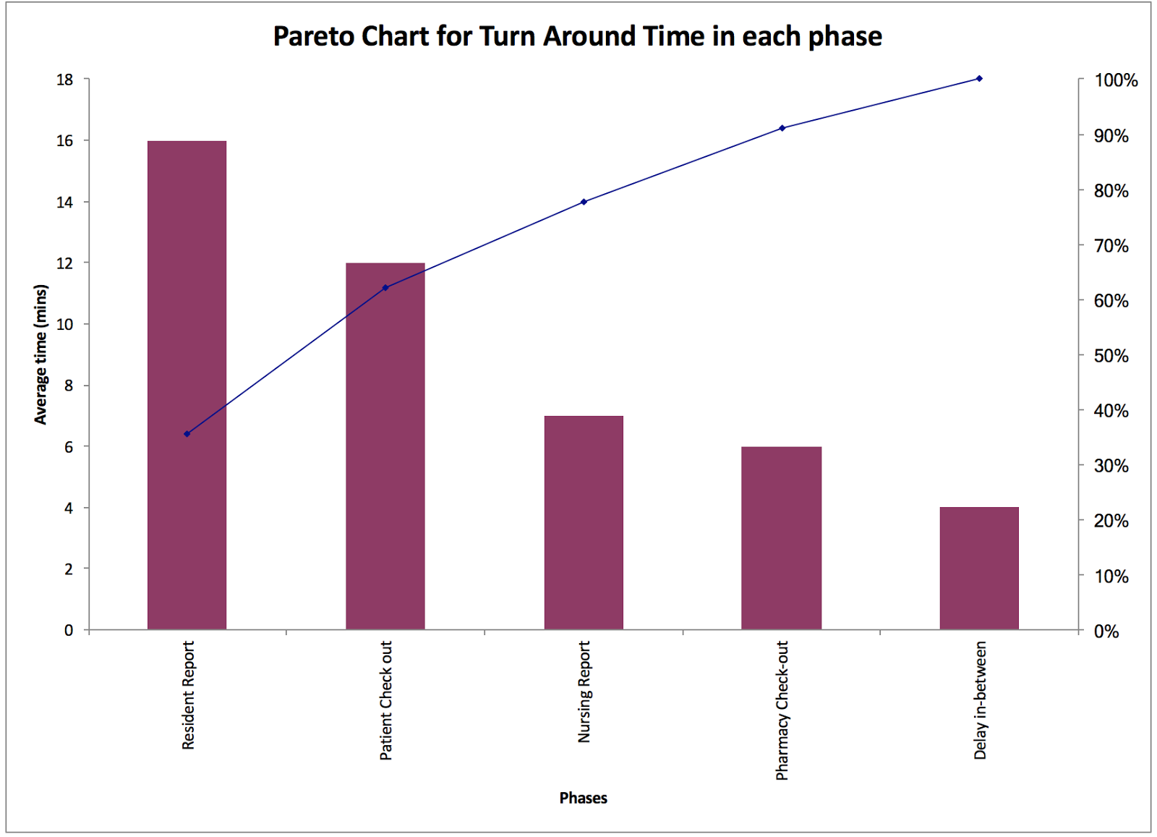

Figure 1. Pareto Chart of Turn Around Time

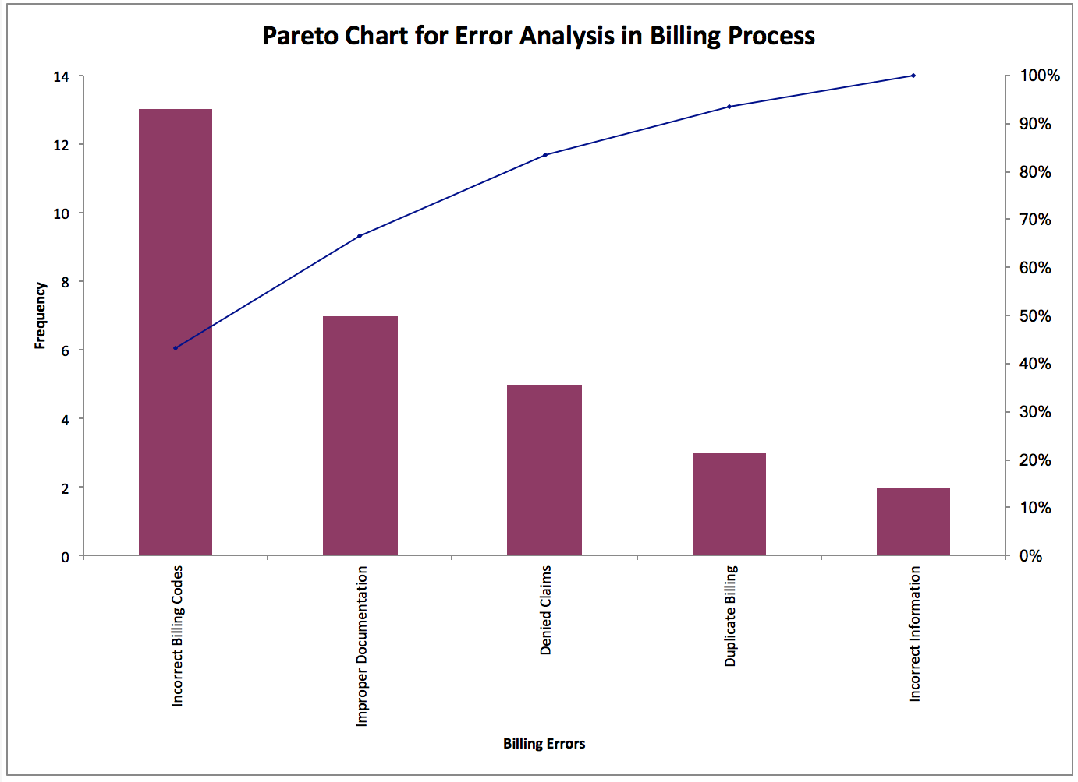

Figure 2. Pareto Chart of Billing Error

# Analyze Phase

Analyze is the third step in DMAIC. In this phase, root cause analysis is done to get a detailed report for the problem. Ishikawa diagram is done to focus on the causes for the effects identified in the Pareto analysis. Then a Root Cause Validation is done to validate the major causes for the same and then the project team proposes a solution for improvement.

The “as is” analysis of the process followed by the XYZ healthcare is done and the following observation are found.

## Ishikawa Diagram

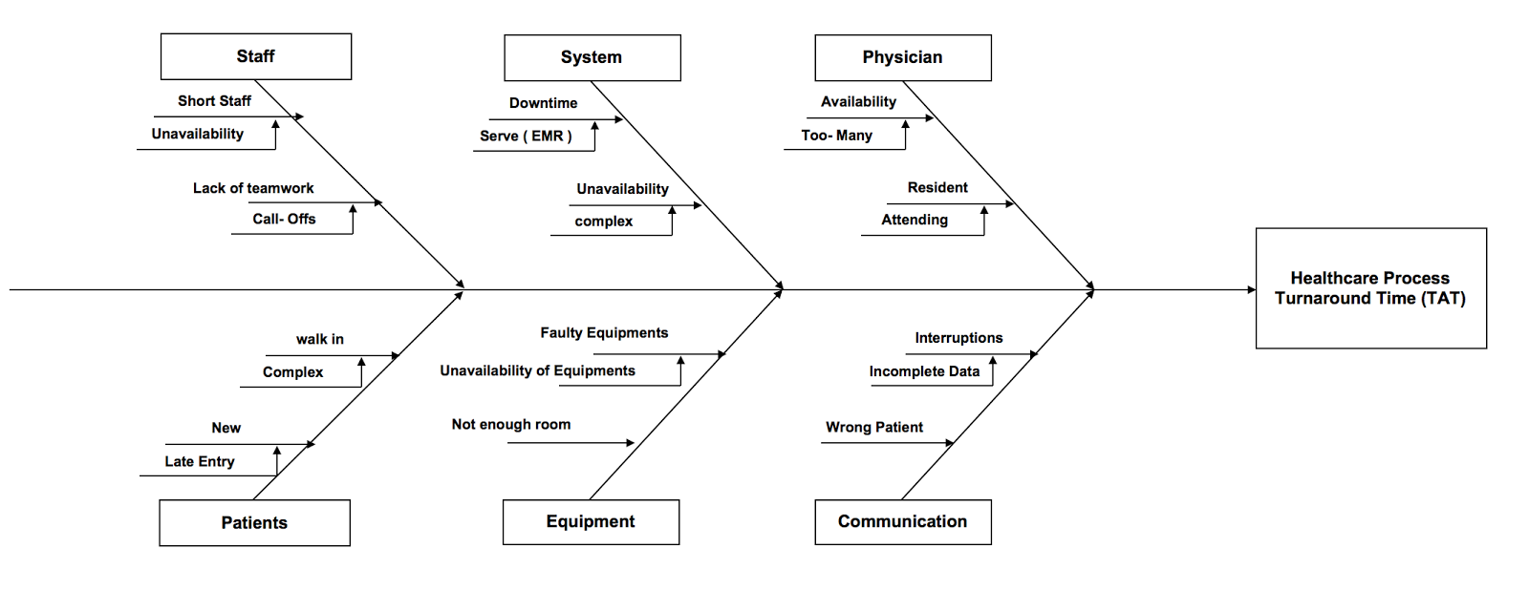

Figure 3. Ishikawa Diagram

## Root Cause Validation

|  |  |  |
| --- | --- | --- |
| **Cause Description** | **Significant** | **Non-Significant** |
| Lack of communication gap between staff & provider | V |  |
| Lack of training to the coders and providers | V |  |
| Employees not following standard procedure | V |  |
| Entering different codes than given codes. | V |  |
| Missing codes in the billing process | V |  |
| Missing Payer / Provider information | V |  |
| Incomplete information of the payer / provider. | V |  |
| Patient’s insurance policy not checked. | V |  |
| Inaccurate bill submitted to the payer. | V |  |
| Wrong treatment code entered in bill. | V |  |
| List of treatment codes not available with coders. |  | V |
| Codes were updated. |  | V |

Table 5. Root Cause Validation

# Improve Phase

Improve phase is one of the important phase in DMAIC process. The main purpose of this improve phase is to identify the root cause of the problem the process currently face and to overcome with the feasible solution. The current status of the company is analyzed in the Analyze phase and improvements are suggested to company to overcome the problems with the best possible method.

In the analyze phase, the potential causes for the delay in billing is analyzed and in improve phase, we used the root cause analysis method to identify the root cause of the problem. In addition to the root cause analysis we have also used the FMEA method to identify the problems.

## Failure Mode and Effects Analysis (FMEA)

Failure Modes and Effects Analysis (FMEA) is a systematic step-by-step approach which is used for identifying the potential causes of the problem. The identified problems were then analyzed for feasible solutions. FMEA method is carried out throughout the process to improve the performance and to reduce the cost and time.

In order to do FMEA method, the potential risks in the process were identified and based on the severity, occurrence and detection, Risk Priority Numbering (RPN) is used.

Risk Priority Numbering = Severity * Occurrence * Detection

The severity, occurrence and the detection values ranges from 1 – 10 depending upon the problem.

### RPN Prioritization Table

|  |  |  |
| --- | --- | --- |
| **Priority** | **RPN** | **Action Required** |
| Critical | >350 | Unacceptable risk; failure mode shall be eliminated. |
| High | 101-350 | Failure mode severity and/or probability of occurrence shall be reduced to bring down RPN to "Low". |
| Low | < 100 | Acceptable risk; at team's discretion, investigate design modifications, alternative designs, or incorporate preventive maintenance program to reduce risk. |

Table 6. RPN Prioritization Table

### FMEA Table

|  |  |  |  |  |  |  |  |  |  |  |  |  |  |  |
| --- | --- | --- | --- | --- | --- | --- | --- | --- | --- | --- | --- | --- | --- | --- |
| **Process Step/Input or Design Item** | **Potential Failure Mode** | **Potential Effect(s) of Failure** | **SEV** | **Potential Cause(s)/Mechanism of Failure** | **OCC** | **Current Process Controls to Prevent Failure** | **DET** | **RPN** | **Recommended Actions** | **Person Responsible for Actions** | **SEV** | **OCC** | **DET** | **RPN** |
| Due to Billing Errors. | Entering incorrect information by the provider. | Increases the billing time. | 7 | Lack of support and adequate training not given. | 8 | No control measures. | 7 | 392 | Provide trainings to the providers periodically and establish support system. | Management | 7 | 3 | 3 | 63 |
| Entering incorrect information of the patient. | Delay in processing the billing | 8 | Lack of information provided. | 4 | Entering available information. | 3 | 96 | Coordinate with the concerned people and obtain the required information. | Staff | 6 | 2 | 2 | 24 |
| Inaccurate data(Code) entry. | Delay the billing process. | 8 | Lack of training for the coder. Lack of support from the provider. | 5 | Inaccurate coding / incomplete coding. | 5 | 200 | Required training must be provided for the staff’s. | Management | 5 | 2 | 3 | 30 |
| Not verifying patient’s insurance coverage. | Delay in the billing process and increases the billing cycle. | 7 | Lack of training for the staff. | 7 | Provider / payer coordinate with insurance company to finalize billing. | 5 | 245 | Required training must be provided for the staff’s. | Management. | 5 | 2 | 2 | 20 |
| Inaccurate Bill submitted to Payer. | Increases billing cycle. | 8 | Inaccurate codes by coders / incomplete document from the provider | 2 | Corrected based on complaints from payer. | 3 | 48 | Adequate training is provided to provider and coders. Coders verify with doctors in case of any queries. | Management / Staff | 6 | 2 | 2 | 24 |

Table 7. FEMA Table

## Root Cause Analysis and Feasible Solution

|  |  |  |
| --- | --- | --- |
| **Root cause** | **Major Sub Causes** | **Feasible Solutions** |
| Delay in billing process. | Not following standard procedure. Entering incorrect / incomplete information for the provider / patient / insurance provider. | Follow the standard procedure. Collect all the required information from the provider / patient / insurance provider and enter them appropriately. |
| Entering wrong codes or missing some codes provided by the provider. | Follow-up with provider to verify the codes in case of any queries. Maintain clear documentation process, which helps providers to enter respective codes. |
| Inaccurate bill submitted to the payer. | All the treatment provided by the provider must be entered in the bill and a final check must be done prior to delivering the bill to the payer. Verification process to make sure that the patient is charged for what he has been treated for. |
| Not verifying Insurance coverage of the patients. | Patient’s insurance policy must be verified before starting the treatment. Patient / Insurance provider must be notified about the policy prior to the billing process. |
| Duplicate billing / Inaccurate bill submitted to the payer. | All the bills must be verified with the patient’s treatment history and patient should be charged only for the treatment taken and other charges. Inaccurate bills should be totally avoided, which leads to revenue loss to the hospital. |

Table 8. Root Cause Analysis and Feasible Solution

## Improvement using 5S

Improving the efficiency of the existing process depends on reducing or eliminating the waste in the environment in which the process occurs. We decided to use 5S, a Lean tool as a potential solution for improving the overall process cycle in the health center and reducing the billing errors in the system. 5S refers to five Japanese words, Seiri, Seiton, Seisou, Seiketsu, and Shitsuke, which generally means maintaining the environment clean and reducing the waste.

* Sort: Unnecessary items, outdated items, expired products and unnecessary documents can be sorted out and eliminated. This saves a lot work area and clears the space.
* Straighten: In this step, hospitals can organize the specific equipment to create more space for storage, to create better quality care and treatment and reducing inventory waste.
* Shine: In this step, we identify the areas which would degrade the quality of the health center system. Create a safety environment and improve the experience of patients. Improve the cleaning standards in the environment.
* Standardize: Develop a standard protocol for implementing the above steps, monitoring, and planning of the actions that has to be taken to accomplish our goal.
* Sustain: After implementing the above “S’s” maintaining and sustaining an efficient environment is challenging phase. After incorporating the 5S approach, maintaining the efficiency is very crucial.

## Learning and Future Improvement Ideas

### Key Learning

* Lean doesn’t give you drastic or rapid results, it takes time gradually goals can be reached.
* Lean can be implemented in all the areas of the organization.
* Enough time has to be allocated to develop a plan and implement it.
* Communication is very crucial for good team-work.
* We have to sort the priorities and take actions
* Involve the staff in planning and execution phase and identify the champions in each work area.
* Maintaining and sustaining the improvements is one of the greatest challenges.

### Future Improvement Ideas

* Better electronic medical record system to maintain billing system and claims.
* More staff training and open channel for staff to speak and give suggestions.
* Advanced program which helps physicians to directly feed in medical codes.
* Self-check-in counter for patients which would save lot of time.

# Control Phase

## Control Chart

To sustain and control the improvements, the team utilized an individual control chart. Monitoring the TAT helped to ensure that the process stayed in control, was stable and met the quality of treatment and patient’s expectations.

### Before Process

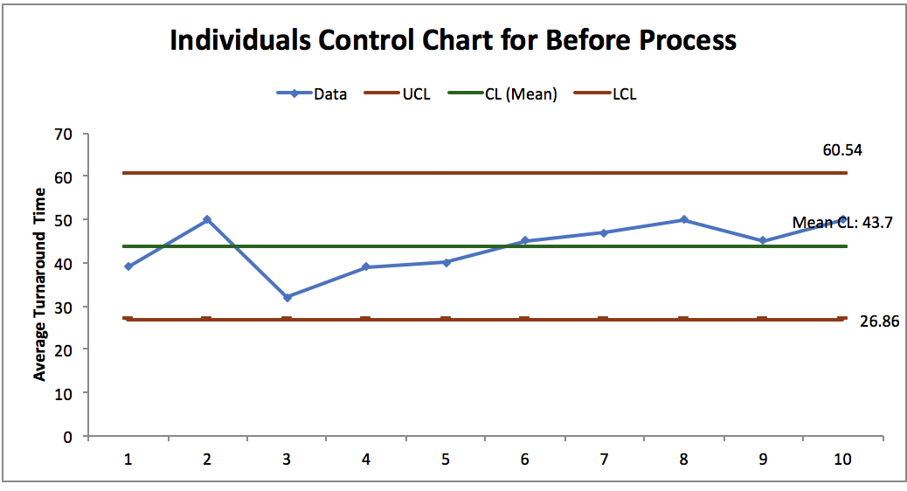

Figure 4. Control Chart Before Process

### After Process

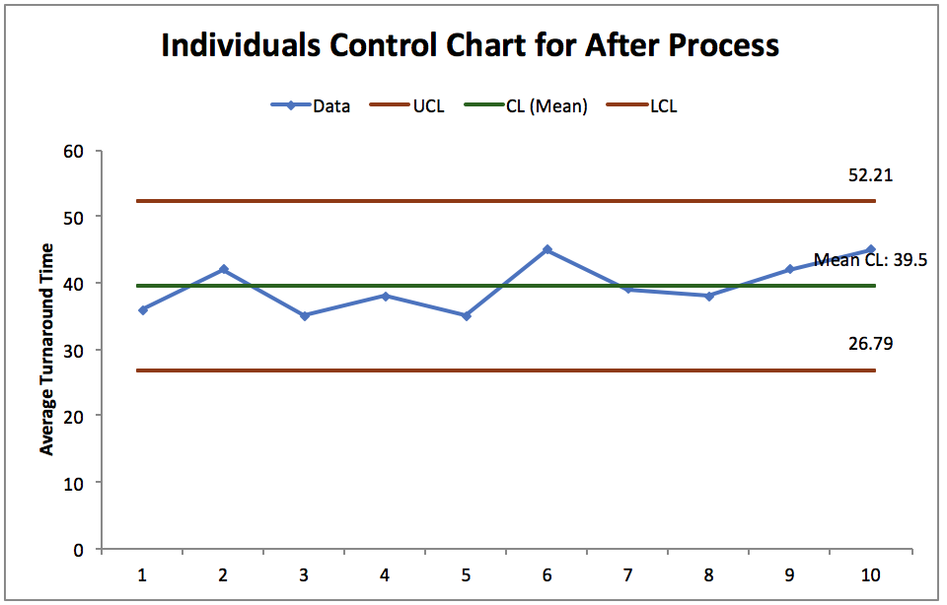

Figure 5. Control Chart After Process

## Hypothesis Testing

### Turn Around Time

The assumption that the population is normally distributed is made. The variance of the population is unknown. First, F-test is used to determine whether there is enough evidence to reject the claim that the variances are the same. The p-value is 0.397 which is greater than α = 0.05. The test fails to reject the null hypothesis. There is not enough evidence to reject that the variances are the same. The assumption that the variances are the same is made. Then, the T-test with equal variance is used to test that whether there is enough evidence to show that the TAT after improvement is shorter than TAT before improvement. The p-value is 0.065 which is greater than α = 0.05. The test fails to reject the hull hypothesis. There is not enough evidence to support the claim that the TAT after improvement is shorter than TAT before improvement.

|  |  |
| --- | --- |
| **TAT Before Improvement** | **TAT After Improvement** |
| 39 | 35 |
| 50 | 45 |
| 32 | 34 |
| 39 | 36 |
| 40 | 30 |
| 45 | 46 |
| 47 | 42 |
| 50 | 40 |
| 45 | 43 |
| 50 | 45 |

Table 9. TAT Before and After

|  |  |  |
| --- | --- | --- |
| F-Test Two-Sample for Variances | | |
|  | *TAT(Before)* | *TAT(After)* |
| Mean | 43.7 | 39.6 |
| Variance | 36.45555556 | 30.48888889 |
| Observations | 10 | 10 |
| df | 9 | 9 |
| F | 1.195699708 |  |
| P(F<=f) one-tail | 0.397200818 |  |
| F Critical one-tail | 3.178893104 |  |

Table 10. F-test

|  |  |  |
| --- | --- | --- |
| t-Test: Two-Sample Assuming Equal Variances | | |
|  | *TAT(Before)* | *TAT(After)* |
| Mean | 43.7 | 39.6 |
| Variance | 36.45555556 | 30.48888889 |
| Observations | 10 | 10 |
| Pooled Variance | 33.47222222 |  |
| Hypothesized Mean Difference | 0 |  |
| df | 18 |  |
| t Stat | 1.584625301 |  |
| P(T<=t) one-tail | 0.065231374 |  |
| t Critical one-tail | 1.734063607 |  |
| P(T<=t) two-tail | 0.130462747 |  |
| t Critical two-tail | 2.10092204 |  |

Table 11. T-test Assuming Equal Variances

### Error Frequency

The assumption that the population is normally distributed is made. The two data sets are paired sample, so the T-test is used to test that whether there is enough evidence to show that the difference between the error frequency before improvement and the error frequency after improvement is greater than 0. The p-value is 0.041 which is less than α = 0.05. The test reject the null hypothesis. There is strong evidence to show that the difference between the error frequency before improvement and the error frequency after improvement is greater than 0.

|  |  |  |
| --- | --- | --- |
| **Billing Errors** | **Before** | **After** |
| Improper Documentation | 7 | 5 |
| Duplicate Billing | 3 | 2 |
| Incorrect Billing Codes | 13 | 6 |
| Denied Claims | 5 | 3 |
| Incorrect Information | 2 | 1 |

Table 12. Error Frequency Before and After

|  |  |  |
| --- | --- | --- |
| t-Test: Paired Two Sample for Means | | |
|  | *Error Frequency(Before)* | *Error Frequency(After)* |
| Mean | 6 | 3.4 |
| Variance | 19 | 4.3 |
| Observations | 5 | 5 |
| Pearson Correlation | 0.940389773 |  |
| Hypothesized Mean Difference | 0 |  |
| df | 4 |  |
| t Stat | 2.316264097 |  |
| P(T<=t) one-tail | 0.04073499 |  |
| t Critical one-tail | 2.131846786 |  |
| P(T<=t) two-tail | 0.08146998 |  |
| t Critical two-tail | 2.776445105 |  |

Table 13. T-test Paired Sample

# Conclusion

According to the data sets of TAT, the average TAT after improvement is lower than the average TAT before improvement. However, the result of the hypothesis test shows that there is not enough evidence to support the claim that the average TAT after improvement is lower than the average TAT before improvement. Although there is not enough evidence to show that the project succeeds in reducing the TAT, it is proved that there is significant difference between error frequency before improvement and error frequency after improvement.

The project doesn’t accomplish its goal, but it does not totally fail. Due to the short time duration of the project, the improvement process could still be in the transforming phase. The staff may need more time to get familiar with the new working environment. However, the project still reduces the occurring of errors. With continuous control and more resources available, the project could get a better result.

# Appendix

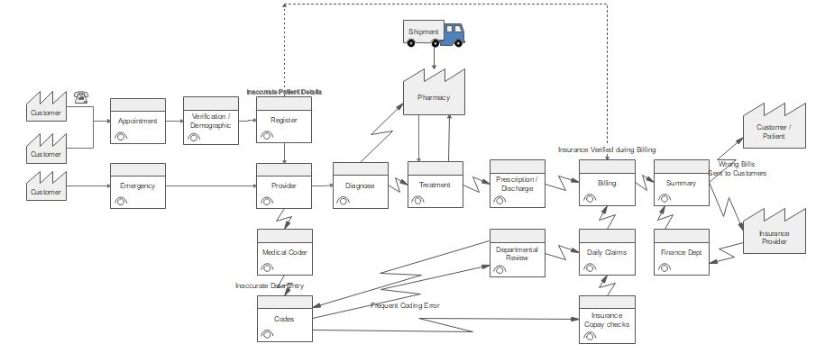

Figure 6. Value Stream Mapping Before State

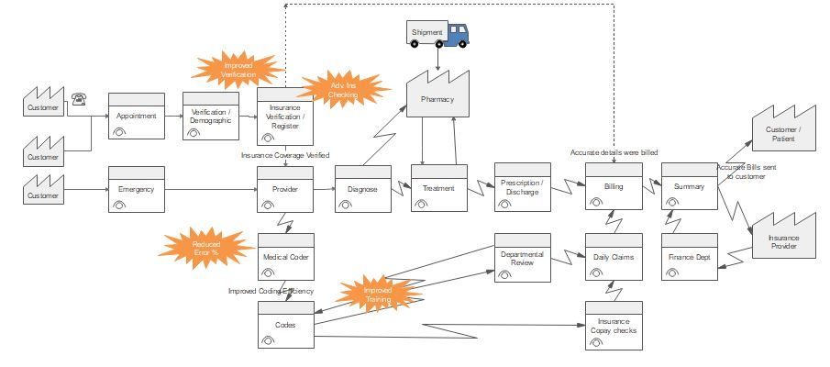

Figure 7. Value Stream Mapping After State

# References

Steele, D (2017a). Managing the Lean Enterprise Improvement Program. Retrieved November 1, 2017, from: https://sjsu.instructure.com/courses/1243813/files/folder/Lecture%20Files

Steele, D (2017b). Business Process Improvement. Retrieved November 1, 2017, from: https://sjsu.instructure.com/courses/1243813/files/folder/Lecture%20Files

Steele, D (2017c). Lean Production System. Retrieved November 1, 2017, from: https://sjsu.instructure.com/courses/1243813/files/folder/Lecture%20Files

Steele, D (2017d). Management System. Retrieved November 1, 2017, from: https://sjsu.instructure.com/courses/1243813/files/folder/Lecture%20Files

Steele, D (2017e). Standardized Work. Retrieved November 1, 2017, from: https://sjsu.instructure.com/courses/1243813/files/folder/Lecture%20Files

Steele, D (2017f). Visual Controls. Retrieved November 1, 2017, from: https://sjsu.instructure.com/courses/1243813/files/folder/Lecture%20Files

Steele, D (2017g). Daily Accountability Process. Retrieved November 1, 2017, from: https://sjsu.instructure.com/courses/1243813/files/folder/Lecture%20Files

Steele, D (2017h). Lean in Administrative, Technical, and Professional Work. Retrieved November 1, 2017, from: https://sjsu.instructure.com/courses/1243813/files/folder/Lecture%20Files

Steele, D (2017i). Lean Management: The Sensei and Gemba Walks. Retrieved November 1, 2017, from: https://sjsu.instructure.com/courses/1243813/files/folder/Lecture%20Files

Steele, D (2017j). Leading the Lean Operation. Retrieved November 1, 2017, from: https://sjsu.instructure.com/courses/1243813/files/folder/Lecture%20Files

Steele, D (2017k). Rapid Problem Solving and Process Improvement. Retrieved November 1, 2017, from: https://sjsu.instructure.com/courses/1243813/files/folder/Lecture%20Files

Steele, D (2017l). People. Retrieved November 1, 2017, from: https://sjsu.instructure.com/courses/1243813/files/folder/Lecture%20Files

Steele, D (2017m). Sustaining the Implementation. Retrieved November 1, 2017, from: https://sjsu.instructure.com/courses/1243813/files/folder/Lecture%20Files